**Assignment -2**

|  |  |
| --- | --- |
| Assignment Date | 19 September 2022 |
| Student Name | Gopinath A |
| Student Roll Number | 810019104020 |
| Maximum Marks | 2 Marks |

**Question:**

Upload the dataset to Cognos Analytics, prepare the data, explore and Create Interactive

Dashboard.

**Task 1:** Sales By Customer.

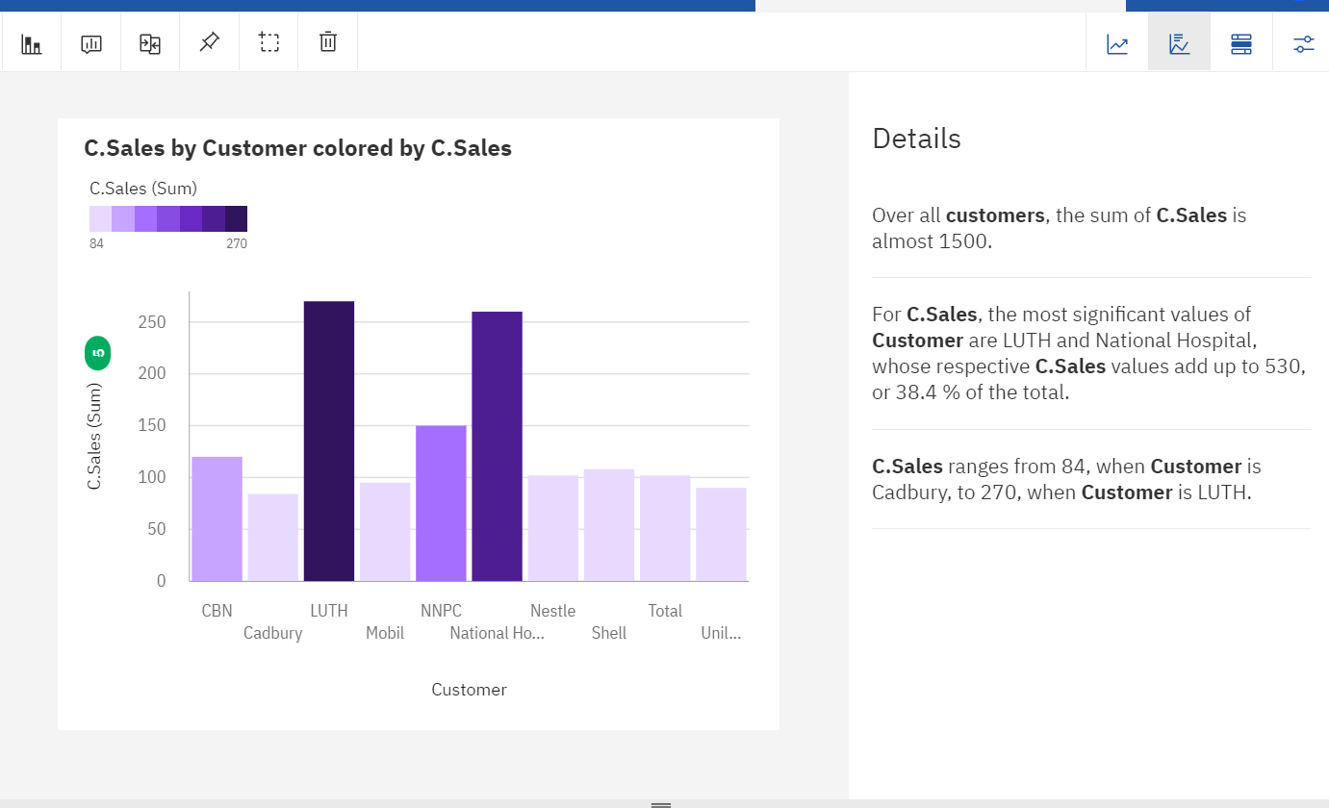

**Task 2:** Sales By Location.

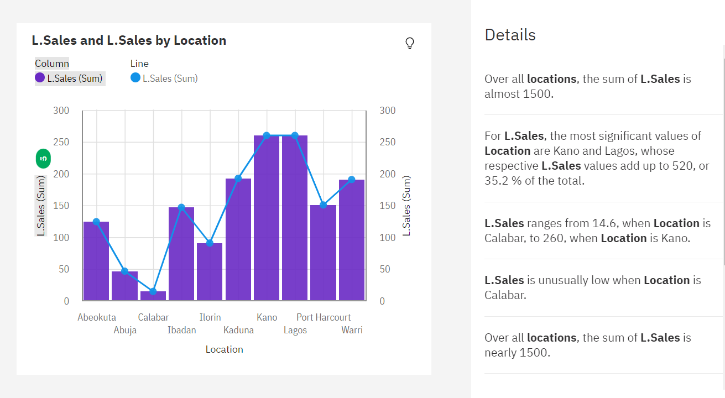

**Task 3:** Sales By Sales Representative.

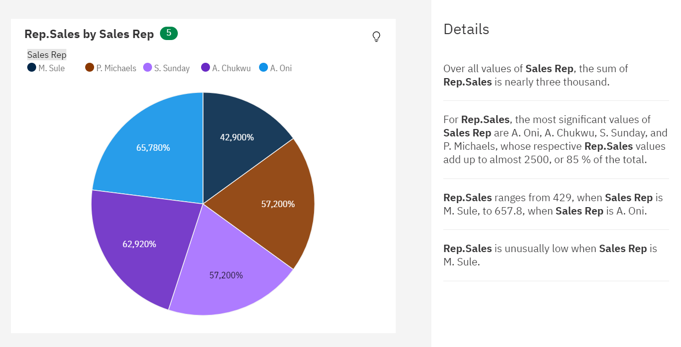

**Task 4:** Received Inventory From Supplier

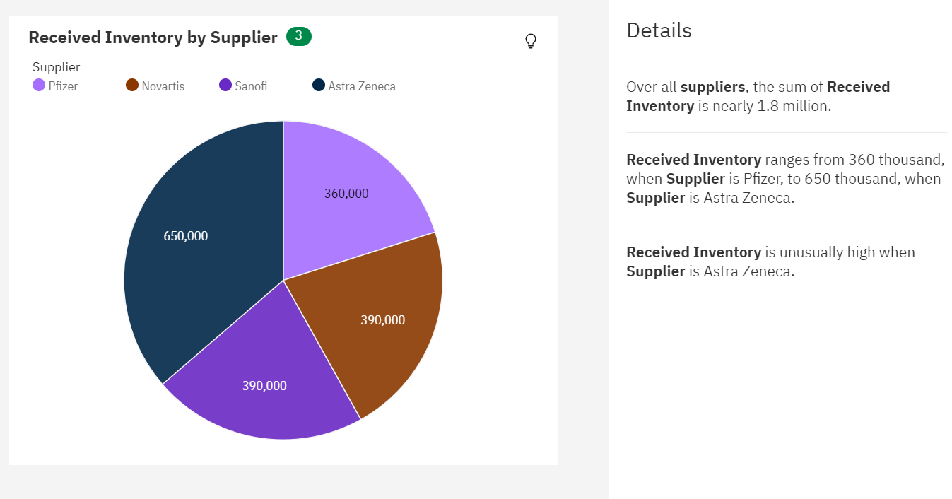

**Task 5:** Inventory Stock for Warehouse Locations

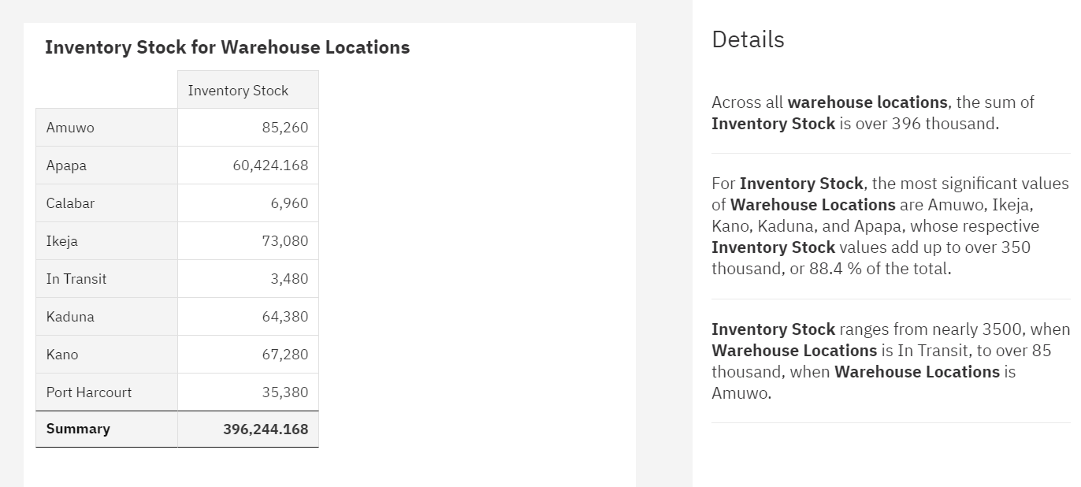

**Task 6**: Sales Trend

**Task 7:** Monthly Sales

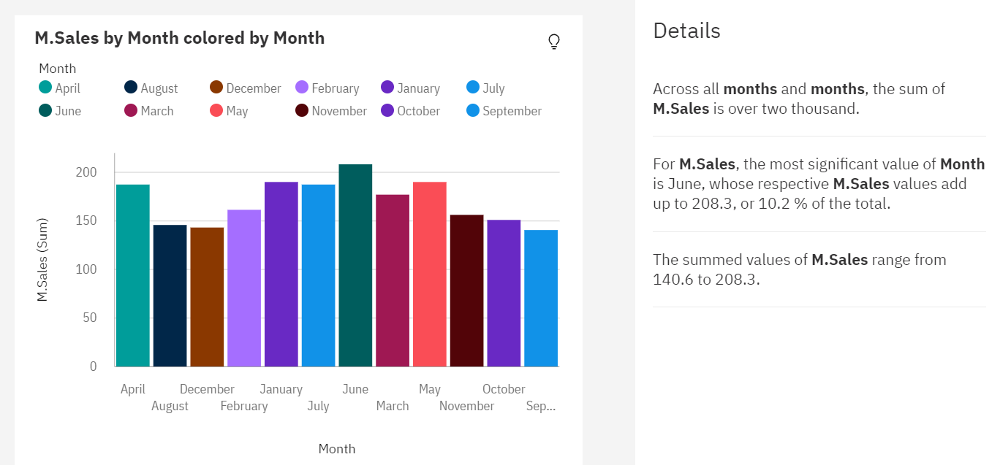

**Task 8:** Actual and Received Inventory by Month



  
  
  
    
    
    
    
    
    
    
    
    